1. Look at the pictures below. Tick all the things that use electricity.
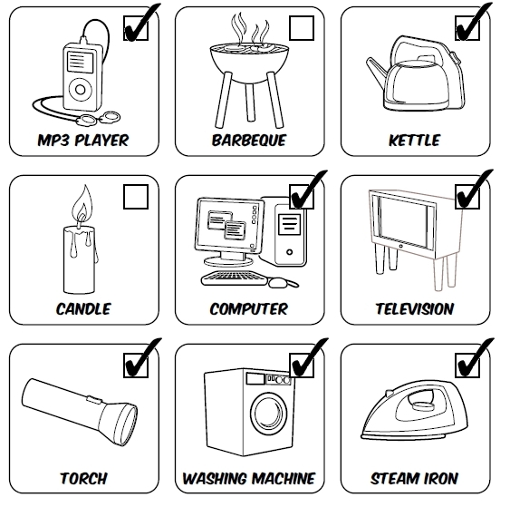

2. Why is mains electricity more dangerous than batteries?
Answer: It is very dangerous because it is so powerful. Mains electricity could severely hurt or_
kill you.______________________________________________________________________
________________________________________________________________________________________________________________________________________________________

3. Why must you never have electrical appliances in the bathroom?
Answer: Electricity and water are very dangerous together because water conducts electricity. It could kill you._________________________________________________________________
________________________________________________________________________________________________________________________________________________________

4. Look at the dangerous pictures below. What is wrong? Why? Write your answers in the spaces below the pictures.
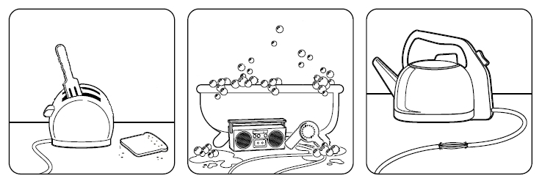

Answer: Never poke anything into a toaster. You could get__
an electric shock.__________
________________________
________________________
Answer: Never take electrical_
appliances into the bathroom_
or touch anything electrical___
with wet hands. It could badly_
hurt or kill you.____________
Answer: The kettle is very___ dangerous. The flex is worn._ Never touch bare electrical__ wires. They could badly hurt or kill you.__________________

5. True or false?
✓
Water conducts electricity True False

✓
Electricity can jump True False
✓
Electricity can severely burn or kill you if not used properly True False

6. Write 3 facts about batteries.
Potential answer: 1. There are chemicals inside a battery. 2. A battery has a positive (+) and a_ negative (-) end. 3. The chemicals inside make positive and negative charges. 4. Batteries are used to store electricity._________________________________________________________
____________________________________________________________________________

7. Write 3 facts about electricity.
Potential answers: 1. Electricity is very dangerous. 2. It is very powerful. 3. The bigger the___ voltage the more powerful it is. 4. Electricity in your home is connected to a meter. 5. Electricity in your home is connected to a fuse box. 6. It goes around your house on a ring main._______
____________________________________________________________________________

